THE FIVE WOUNDS
OF THE CRUCIFIED CHRIST

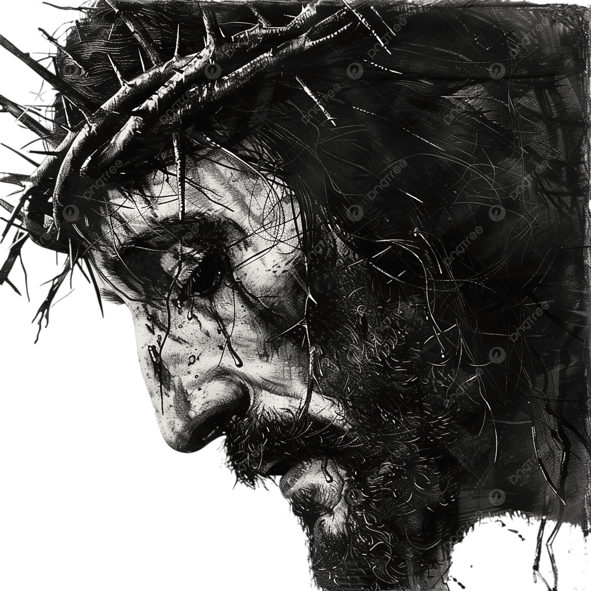

The Fifth Wound: The Head of Christ.

We adore you, O Christ, and we bless You,
because, by Your Holy Cross,
You have redeemed the world.

St. Mary, Star of the Sea, Largs
Our Lady of Perpetual Succour, Millport

The website of the Shroud of Turin (www.shroud.com) tells us that the crown of thorns, likely fashioned from rigid, long-spiked Bethlehem or date palm thorns, was hammered onto Jesus' head as a cap, causing approximately 50 puncture wounds. This brutal headpiece caused extreme pain, including severe nervous system stimulation, and induced heavy scalp bleeding that flowed down his face, neck, and back.

Nature and Severity of the Wounds

- Structure: Unlike the thin circle often depicted, forensic analysis of the Shroud of Turin suggests a "helmet" or cap-like structure that covered the entire top and sides of the head.
- Puncture Sites: Roughly 50 distinct punctures are estimated, concentrating on the forehead, top of the head, and nape of the neck.
- Deep Tissue Damage: The thorns, which could be up to 12 inches long, were reported to have been pushed into the skull with such force that they pierced through skin and pressed into the bone.
- Severe Bleeding: Because the scalp is highly vascularized, the injuries led to profuse blood loss. The Shroud reveals blood flowing down the face, with a distinct "3" or "omega" shaped clot on the forehead.
- Nerve Damage: The injuries likely affected the trigeminal and occipital nerves, causing intense pain, headaches, and facial spasms, which were worsened by the soldiers striking the crown.
- Intensity: The pain would have been constant, intensified when the soldiers struck his head with a reed or when the crown was removed and reapplied.

Biblical References:

- Matthew 27:29: “They then twisted together a crown of thorns and set it on his head. They put a staff in his right hand. Then they knelt in front of him and mocked him. “Hail, king of the Jews!” they said.”
- Mark 15:17: “And they clothed him with purple, and platted a crown of thorns, and put it about his head”
- John 19:2-5: “And the soldiers platted a crown of thorns, and put it on his head, and they put on him a purple robe, and said, Hail, King of the Jews! and they smote him with their hands. Pilate therefore went forth again, and saith unto them, Behold, I bring him forth to you, that ye may know that I find no fault in him. Then came Jesus forth, wearing the crown of thorns, and the purple robe. And Pilate saith unto them, Behold the man!”

The crown was used by Roman soldiers to mock Jesus’ title as “King of the Jews.” In its own way it echoes the cynicism of Pilate when, on hearing Jesus speak of His kingdom as an other-worldly realm and as a kingdom of Truth, responds, “Truth, what is that?” (John 18:38).

Reflection & Prayer

When Adam sinned, God said to him, “cursed is the ground because of you; through toil you will eat of it all the days of your life. Both thorns and thistles it will yield you” (Genesis 3: 17-18). Adam crowned himself with thorns as the bitter fruit of sin. But it is Jesus who assumes Adam’s curse of sin and therefore the crown of thorns which it symbolizes. St. Paul tells us that “God made him who had no sin to be sin for us, so that in him we might become the righteousness of God” (2 Corinthians 5:21). Adam had been created in the image and likeness of God to rule over creation under God. “What is man that You are mindful of him, or the son of man that You care for him? You made him a little lower than the angels; You crowned him with glory and honour. You made him ruler of the works of Your hands; You have placed everything under his feet” (Psalm 8:4-6). Adam, sinning, threw his crown of glory into the thornbush, and it became a crown of thorns. But Jesus took on Himself that crown so that, by dying for the race of Adam’s sins, He could again place on our heads the crown of glory, the diadem of redemption. By His wounds, we are healed.

By Your crown of thorns, o Jesus, we are crowned with love and compassion. By being sin for us, You have made us holy for You and the Father. The pain of guilt and shame which afflicts us is no longer ours, but only Yours. Your sacred Head was oppressed that ours might be lifted up in glory. The mockery we make of Your grace and of our own selves passes, all of it, onto You. Thus, by a marvellous exchange, we are glorified and restored to the royal status of the sons and daughters of God! Praise and honour and blessing to You, our Redeemer King!

