SAINT MARY STAR OF THE SEA, LARGS
OUR LADY OF PERPETUAL SUCCOUR, MILLPORT
_______________________

THIRD SUNDAY OF LENT (B)
7 MARCH 2021

Readings

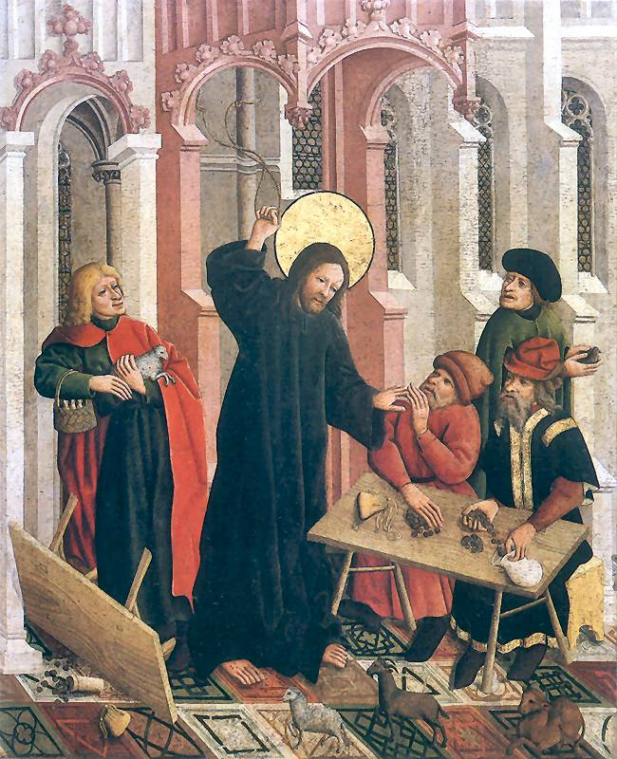

“He drove them all out of the Temple,
cattle and sheep as well,
scattered the money-changers’ coins,
knocked their tables over
and said to the pigeon-sellers,
‘Take all this out of here
and stop turning my Father’s house
into a market.’

(John 2:15-16)

LITURGY OF THE WORD

First Reading Exodus 20:1-17

God spoke all these words. He said, ‘I am the Lord your God who brought you out of the land of Egypt, out of the house of slavery.
‘You shall have no gods except me.
‘You shall not make yourself a carved image or any likeness of anything in heaven or on earth beneath or in the waters under the earth; you shall not bow down to them or serve them. For I, the Lord your God, am a jealous God and I punish the father’s fault in the sons, the grandsons, and the great-grandsons of those who hate me; but I show kindness to thousands of those who love me and keep my commandments.
‘You shall not utter the name of the Lord your God to misuse it, for the Lord will not leave unpunished the man who utters his name to misuse it.
‘Remember the sabbath day and keep it holy. For six days you shall labour and do all your work, but the seventh day is a sabbath for the Lord your God. You shall do no work that day, neither you nor your son nor your daughter nor your servants, men or women, nor your animals nor the stranger who lives with you. For in six days the Lord made the heavens and the earth and the sea and all that these hold, but on the seventh day he rested; that is why the Lord has blessed the sabbath day and made it sacred.
‘Honour your father and your mother so that you may have a long life in the land that the Lord your God has given to you.
‘You shall not kill.
‘You shall not commit adultery.
‘You shall not steal.
‘You shall not bear false witness against your neighbour.
‘You shall not covet your neighbour’s house. You shall not covet your neighbour’s wife, or his servant, man or woman, or his ox, or his donkey, or anything that is his.’

Responsorial Psalm 18 (19): 8-11

You, Lord, have the message of eternal life.

Second Reading 1 Corinthians 1:22-25

While the Jews demand miracles and the Greeks look for wisdom, here are we preaching a crucified Christ; to the Jews an obstacle that they cannot get over, to the pagans madness, but to those who have been called, whether they are Jews or Greeks, a Christ who is the power and the wisdom of God. For God’s foolishness is wiser than human wisdom, and God’s weakness is stronger than human strength.

Gospel John 2:13-25

Just before the Jewish Passover Jesus went up to Jerusalem, and in the Temple he found people selling cattle and sheep and pigeons, and the money-changers sitting at their counters there. Making a whip out of some cord, he drove them all out of the Temple, cattle and sheep as well, scattered the money-changers’ coins, knocked their tables over and said to the pigeon-sellers, ‘Take all this out of here and stop turning my Father’s house into a market.’ Then his disciples remembered the words of scripture: Zeal for your house will devour me. The Jews intervened and said, ‘What sign can you show us to justify what you have done?’ Jesus answered, ‘Destroy this sanctuary, and in three days I will raise it up.’ The Jews replied, ‘It has taken forty-six years to build this sanctuary: are you going to raise it up in three days?’ But he was speaking of the sanctuary that was his body, and when Jesus rose from the dead, his disciples remembered that he had said this, and they believed the scripture and the words he had said.
During his stay in Jerusalem for the Passover many believed in his name when they saw the signs that he gave, but Jesus knew them all and did not trust himself to them; he never needed evidence about any man; he could tell what a man had in him.

LITURGY OF THE EUCHARIST

Preface of the Eucharistic Prayer

Spiritual Penance
It is truly right and just, our duty and our salvation,
always and everywhere to give you thanks,
Lord, holy Father, almighty and eternal God.

For you have given your children a sacred time
for the renewing and purifying of their hearts,
that, freed from disordered affections,
they may so deal with the things of this passing world
as to hold rather to the things that eternally endure.

And so, with all the Angels and Saints,
we praise you, as without end we acclaim…

Communion Antiphon

The sparrow finds a home,
and the swallow a nest for her young:
by your altars, O Lord of hosts, my King and my God.
Blessed are they who dwell in your house,
for ever singing your praise
__________

Lent is a time to test the quality of your love for God
and to be unsettled by the immensity of his love for you.

It is a time to give, as well as to give up,
and to explore new ways of giving which go beyond things.

It is a time to ask whether I would truly want to be baptised if I were not baptised. Is the Gospel truly Good News for me and for the world, or do I see it as Old or Fake News?

