SAINT MARY STAR OF THE SEA, LARGS
OUR LADY OF PERPETUAL SUCCOUR, MILLPORT
_______________________

22nd ORDINARY SUNDAY (A)
29-30 AUGUST 2020

Readings

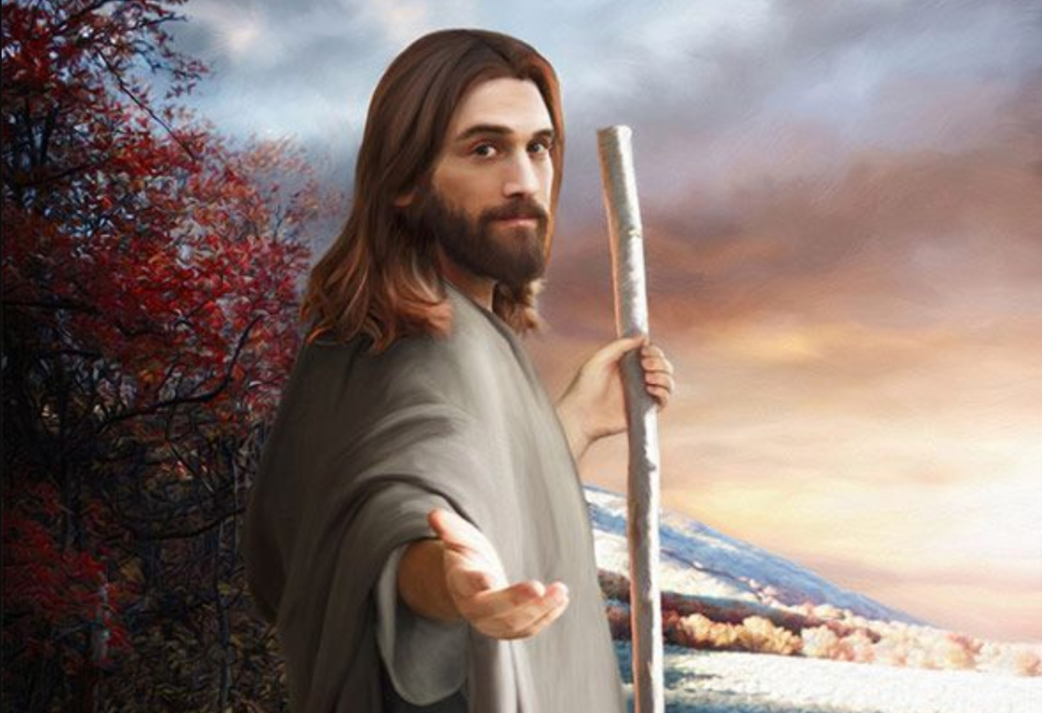

“If anyone wants to be a follower of mine,
let him renounce himself
and take up his cross and follow me.
For anyone who wants to save his life will lose it;
but anyone who loses his life for my sake will find it.
What, then, will a man gain
if he wins the whole world and ruins his life?
Or what has a man to offer in exchange for his life?”

(Matthew 16: 24-26)

THE BODY AS A SACRIFICE PLEASING TO GOD

Through the body we are present to one another. Our body mediates to the other not just the fact of our presence but also how we are present. Body language gives the other a lot of information about me and about my relationship with the other. A gesture of the hand, a turn of the head, the tone of voice: the smallest bodily sign can communicate volumes.

Right from the book of Genesis, the human body not only defines who I am in myself, but also who I am in relation to others and to God. It is especially clear, though, that the body is intended to be the way I make a gift of myself to the other. In the case of marriage, Adam and Eve “become one flesh” as the final, not the first, expression of the gift of love of their whole selves to one another. God intended the body to be the medium which expresses spousal union born of communion, communion of heart and soul revealed in the union of the flesh.

But we also commune with one another in the body without it necessarily being a spousal union. When friends express their deepest selves to one another, they do so in a way that does not violate the spousal meaning of the body. When a group of people get together to serve the poor or the sick, their love is expressed in and through the body in multiple ways.

Jesus took on our humanity in its full carnal and spiritual form. In and through his body, he poured himself out in truth and love and mercy for all who came or responded to him. His body was the living instrument of his self-sacrifice to mankind and to the Father, culminating on the Cross and leading to the Resurrection and to the Eucharist.

Celibacy for the sake of Jesus, for his Kingdom, is a powerful expression of how a man or woman can imitate the living sacrifice of Jesus for the sake of serving God and others. Marriage is another way in which two people accept a living sacrifice of faithful and exclusive love for one another to honour the Creator and to honour Jesus, the Spouse of the Church, his Bride.

St. Paul invites us today to offer our living bodies as a holy sacrifice, pleasing to God. This means loving God in and through our bodies and directing them to his service, whether we are married or celibate. The body is not a thing. It is a gift, a gift to be given as the Giver intended, not consumed and exploited as I like. To live in the body as the Lord wants will allow the body to flourish in true joy, peace and fulfilment.
LITURGY OF THE WORD

First Reading Romans 12:1-2

Think of God’s mercy, my brothers, and worship him, I beg you, in a way that is worthy of thinking beings, by offering your living bodies as a holy sacrifice, truly pleasing to God. Do not model yourselves on the behaviour of the world around you, but let your behaviour change, modelled by your new mind. This is the only way to discover the will of God and know what is good, what it is that God wants, what is the perfect thing to do.

Responsorial Psalm 62(63):2-6,8-9

For you my soul is thirsting, O Lord my God.

Gospel Matthew 16:21-27

Jesus began to make it clear to his disciples that he was destined to go to Jerusalem and suffer grievously at the hands of the elders and chief priests and scribes, to be put to death and to be raised up on the third day. Then, taking him aside, Peter started to remonstrate with him. ‘Heaven preserve you, Lord;’ he said ‘this must not happen to you.’ But he turned and said to Peter, ‘Get behind me, Satan! You are an obstacle in my path, because the way you think is not God’s way but man’s.’
Then Jesus said to his disciples, ‘If anyone wants to be a follower of mine, let him renounce himself and take up his cross and follow me. For anyone who wants to save his life will lose it; but anyone who loses his life for my sake will find it. What, then, will a man gain if he wins the whole world and ruins his life? Or what has a man to offer in exchange for his life?
‘For the Son of Man is going to come in the glory of his Father with his angels, and, when he does, he will reward each one according to his behaviour.’
The Gospel of the Lord.

LITURGY OF THE EUCHARIST

Preface to the Eucharistic Prayer

The pledge of the eternal Passover
It is truly right and just, our duty and our salvation,
always and everywhere to give you thanks,
Lord, holy Father, almighty and eternal God.

For in you we live and move and have our being,
and while in this body
we not only experience the daily effects of your care,
but even now possess the pledge of life eternal.
For, having received the first fruits of the Spirit,
through whom you raised up Jesus from the dead,
we hope for an everlasting share in the Paschal Mystery….

Communion Antiphon
(to be recited privately)

How great is the goodness, Lord,
that you keep for those who fear you.
________

“In the Eucharist, fullness is already achieved; it is the living centre of the universe, the overflowing core of love and of inexhaustible life. Joined to the incarnate Son, present in the Eucharist, the whole cosmos gives thanks to God. Indeed the Eucharist is itself an act of cosmic love: ‘Yes, cosmic! Because even when it is celebrated on the humble altar of a country church, the Eucharist is always in some way celebrated on the altar of the world’” (Pope Francis, “Laudato Si’”, n. 236).

