SAINT MARY STAR OF THE SEA, LARGS
OUR LADY OF PERPETUAL SUCCOUR, MILLPORT
_______________________

17th ORDINARY SUNDAY (A)
25-26 JULY 2020

Readings and Hymns

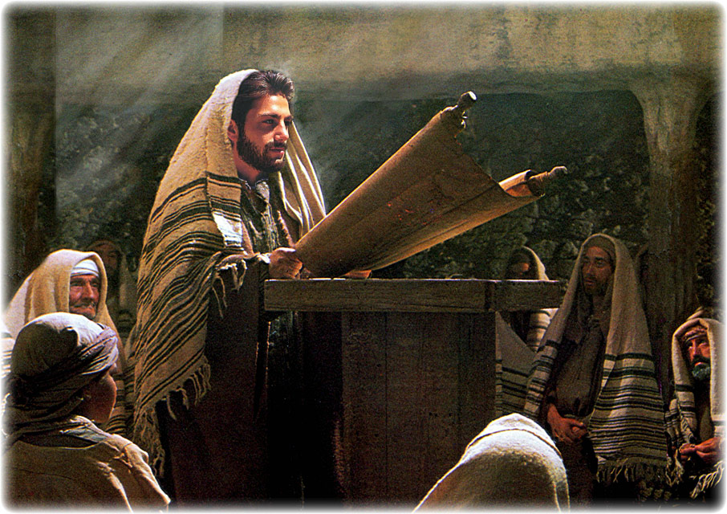

“The kingdom of heaven
is like treasure hidden in a field
which someone has found;
he hides it again, goes off happy,
sells everything he owns
and buys the field.”

(Matthew 13: 44-45)

TEST & TRACE

I like this anti-Covid jingle! It’s not only an effective tool in fighting the virus but could be used in many another context. To test is not just, of course, to stick a thermometer under your tongue to reveal your temperature. Nor is to trace just a question of finding people who might have been infected.

We test and trace all the time. You are visiting a friend for dinner and like the wine served, or the tablecloth or the cutlery. You are impressed, you like it, you take a good look (or taste!). That’s testing. If you’re familiar with your host you will then engage in tracing: “where did you get that? how much? etc.”.

We are constantly testing things and even people in our lives. It’s a case of searching for the truth, for knowledge of the facts. It’s a way of also protecting ourselves from charlatans, from being duped and taken for a ride. But when we find the truth, when we source the genuine article, we pursue it, and depending on what it is, our pursuit may well cost us in time, treasure or talent. It may even cost us everything.

I’ve always admired people who can spot a true gem from a fake, as well as those on TV who are able to put a value on an old vase or book cabinet. It is fascinating to hear them explain why they attach such worth to something or set it aside as worthless.

Sadly, I feel that we have lost today our skills in testing and tracing in matters moral and spiritual. It is so easy to let junk into our homes and, therefore, into our way of thinking and choosing. Someone declares for no other reason than they want to that an age-old value like marriage now means something else, and people drink it in as progressive, or some other buzzword which is supposed to make our hearts flutter.

Today, many do the opposite of the two men in the parables of Jesus in today’s Gospel. We are blessed to have already in our possession the pearl of great price and the treasure in the field, but some joker comes along and tells us that, no, the shiny little trinket he is offering is now the “in thing”, and, without ceremony, we cast aside our inheritance. We have become like Esau, who sold his birthright for a plate of soup.

Christ urges us, however, to test and trace, to seek and find and to sell everything else we own for the treasures he has won and defended for us at the cost of his blood. Why on earth or in heaven would we listen to anyone else? And it’s not because of Covid-19!
Due to Covid-19, there will be no singing at Mass

The Gloria is omitted

LITURGY OF THE WORD

First Reading Romans 8:28-30

We know that by turning everything to their good, God co-operates with all those who love him, with all those he has called according to his purpose. They are the ones he chose specially long ago and intended to become true images of his Son, so that his Son might be the eldest of many brothers. He called those he intended for this; those he called, he justified, and with those he justified he shared his glory.

Responsorial Psalm 118(119):57,72,76-77,127-130

Lord, how I love your law.

Gospel Matthew 13:44-52

Jesus said to the crowds, ‘The kingdom of heaven is like treasure hidden in a field which someone has found; he hides it again, goes off happy, sells everything he owns and buys the field.
‘Again, the kingdom of heaven is like a merchant looking for fine pearls; when he finds one of great value he goes and sells everything he owns and buys it.
‘Again, the kingdom of heaven is like a dragnet cast into the sea that brings in a haul of all kinds. When it is full, the fishermen haul it ashore; then, sitting down, they collect the good ones in a basket and throw away those that are no use. This is how it will be at the end of time: the angels will appear and separate the wicked from the just to throw them into the blazing furnace where there will be weeping and grinding of teeth.
‘Have you understood all this?’ They said, ‘Yes.’ And he said to them, ‘Well then, every scribe who becomes a disciple of the kingdom of heaven is like a householder who brings out from his storeroom things both new and old.’

The Gospel of the Lord.

The Creed is omitted

LITURGY OF THE EUCHARIST

Preface to the Eucharistic Prayer

The mystery of salvation
It is truly right and just, our duty and our salvation,
always and everywhere to give you thanks,
Lord, holy Father, almighty and eternal God,
through Christ our Lord.

For out of compassion for the waywardness that is ours,
he humbled himself and was born of the Virgin;
by the passion of the Cross he freed us from unending death,
and by rising from the dead he gave us life eternal.

And so, with Angels and Archangels,
with Thrones and Dominions,
and with all the hosts and Powers of heaven,
we sing the hymn of your glory,
as without end we acclaim:

Communion Antiphon
(to be recited privately)

Bless the Lord, O my soul,
and never forget all his benefits.

